**Sectional Timing Data and Reports Available**

**What sectional timing data is available?**

Sectional timing data is available for all race meetings in KZN and the Western Cape. The data is being gathered using the McLloyd tracking system, the same system that is in use in France and Hong Kong and is being introduced in Japan. Each horse carries two trackers which record the horses speed, distance travelled, distance relative to other horses and the horse’s position though each 100m sector.

The race-time graphics from the system are displayed on GallopTV and Racing 240, which takes the feed for the race meetings from Gallop also show these graphics.

However graphics are just the visual part of the data and much more is available in the reports.

**Reporting Data**

The data gathered and recorded for each runner is currently available on two platforms:

* **Winning Form** – the data is available on the Winning Form site (available to persons who register on the site and persons with Hollywoodbets accounts) under “Tracking Data”.

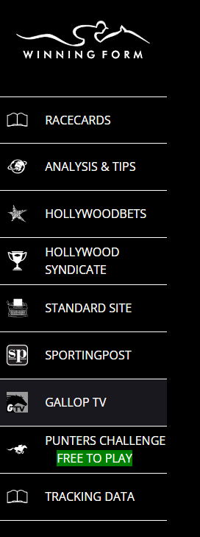

* Raw Data

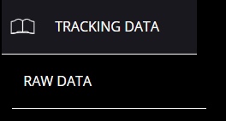

The data is available in “raw” format.

The raw data is available by race meeting, by race and each race is exportable in either CSV or excel formats. Additionally the complete race meeting is available to export in either format.

This will then give the individual user the ability to create bespoke reports for their personal use. People can generate their own data bases etc

The data will be expanded to include other relevant information such as jockey, trainer, weight once the integration with the Winning Form is complete.

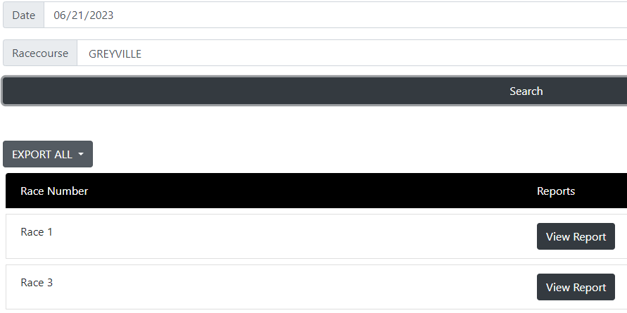

* Sectional Reports

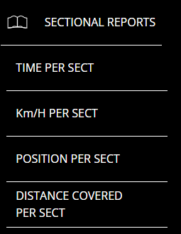

Four basic reports have been created

1. Time Per Sector – this report is available by race and can be exported to CSV or Excel. In addition, the reports for all races may be exported in a single file.

The report shows the time per each 100m sector of the race, and has a summary 800m-400m and 400m to finish time for each horse.

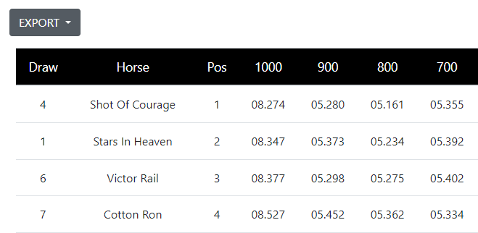

1. Km/H Per Sector – this report shows the speed of each horse per sector and is fully exportable.

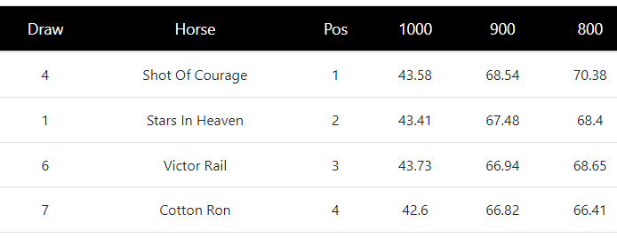

1. Position Per Sector – this report shows each horse’s position per 100m sector and is full exportable

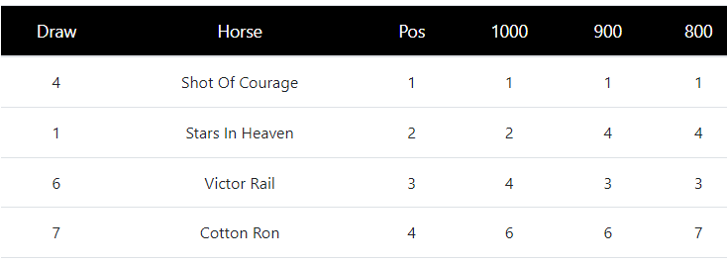

1. Distance Covered Per Sector – this report shows the cumulative distance travelled by each horse through the course of the race. Again, all the date can be exported.

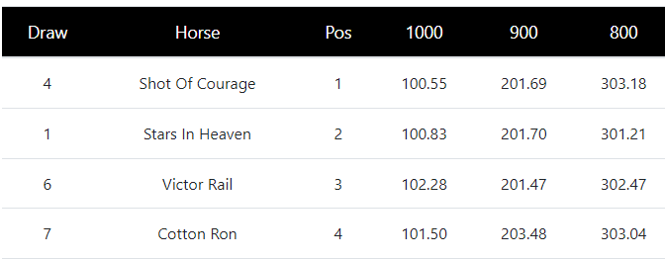

All these reports use the raw data as recorded by the trackers.

* **Gallop.co.za** – the team at Gallop have incorporated the sectional data in their individual race results. They show the official time of the race, the time for the 800m-Finish and the 400m-Finish times, together with the distance travelled by each individual horse.

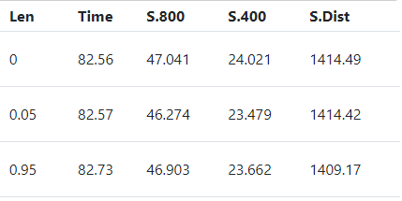

Additionally, behind the little bar graph next to the time of the race, the site displays two reports

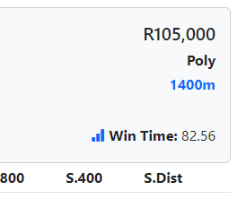

1. The first report shows the position of each horse and the time taken for each 100m sector, colour coded to show the top three quickest.

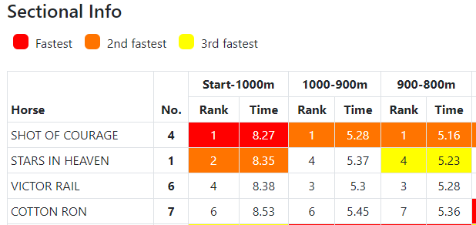

1. The second report shows the maximum speed and average speed for each horse, per sector

